**Docker Introduction**

* **Problems we face with software installation:**

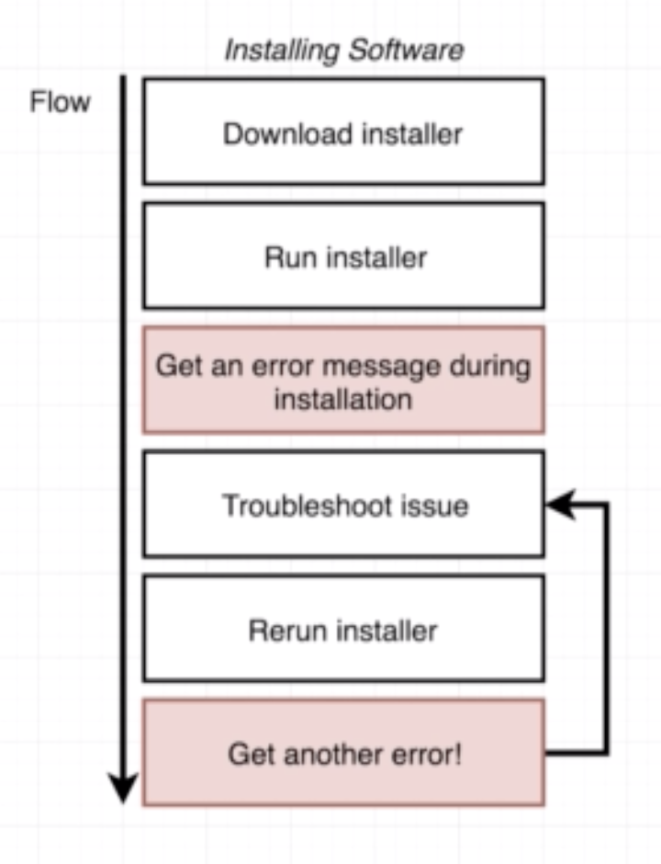

What problem docker solves?

* **What is docker?**

* **Image vs Container:**

* **Installing on Mac OS:**

* **Docker run hello-world and how it works?**

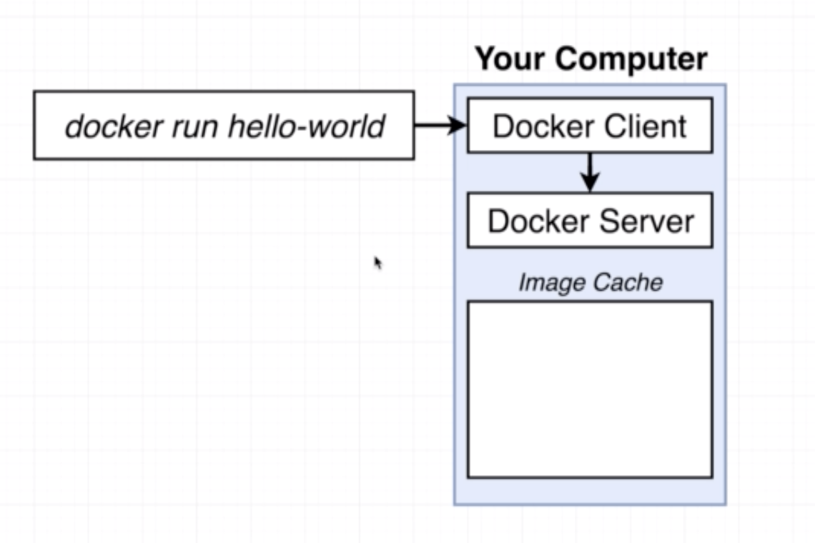

* **What are containers?**

**How OS works?**

**Problem with different application needs different versions of programming language.**

**Use of namespace:**

* **How Docker running on your computer?**

